Digital and media competence for students and teachers
3D printed remote control toy car

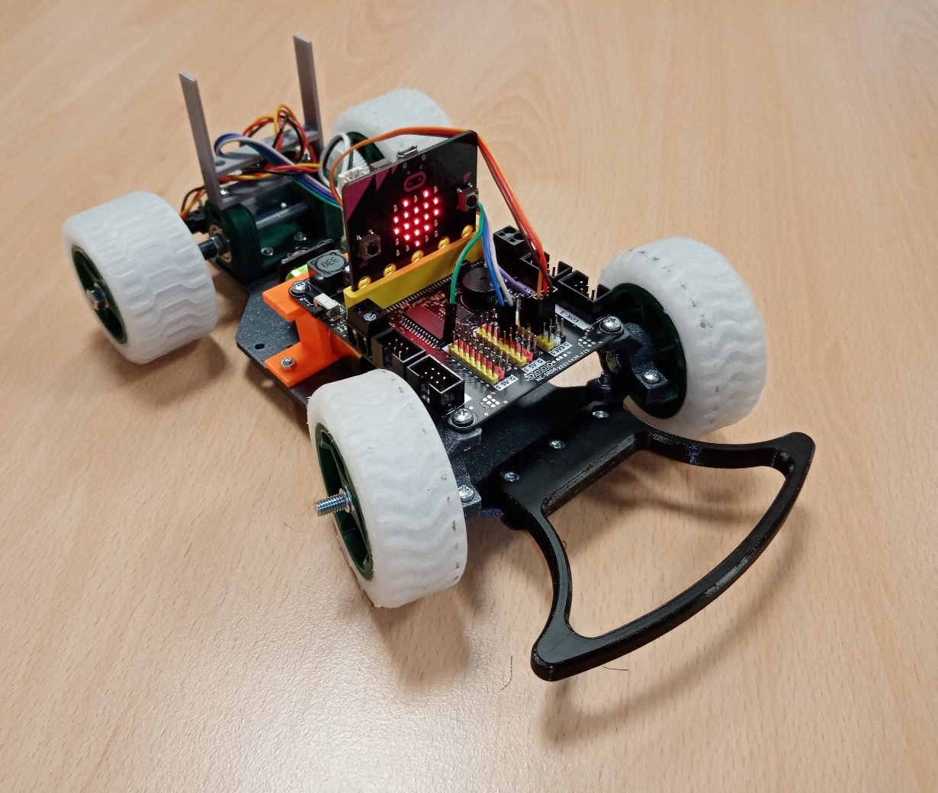

Instructions for implementation – 3D printing, programming in the micro:bit system, building the model step by step

Necessary equipment

- 3D printer (PLA, Flex filaments)
- Hand grinder, e.g. . https://www.nakol.cz/proxxon-28472-presna-vrtaci-bruska-fbs-240e?gclid=EAIaIQobChMImZmzs-i19AIVTLDtCh0SpgXUEAQYAiABEgLPXvD_BwE
- Basic micro:bit Smart home kit + base plate with stab . voltage source
- Hand tools – knife, pliers, flat and socket wrenches, screwdriver, file
- PC for working with online applications:
  - Blockcad3d.com
  - Makecode.microbit.org/,
  - Slicer for the given 3D printer
- Smartphone to work with the EVmicro:bit application
- And especially the desire to do the impossible and the desire to work

Procedure for assembling a toy car
STL files for printing parts are mostly taken over. Some parts need to be modified slightly because the original design uses a different engine and control than was used in this case.
1. Printing of components
• Print all the components that have .stl files attached.

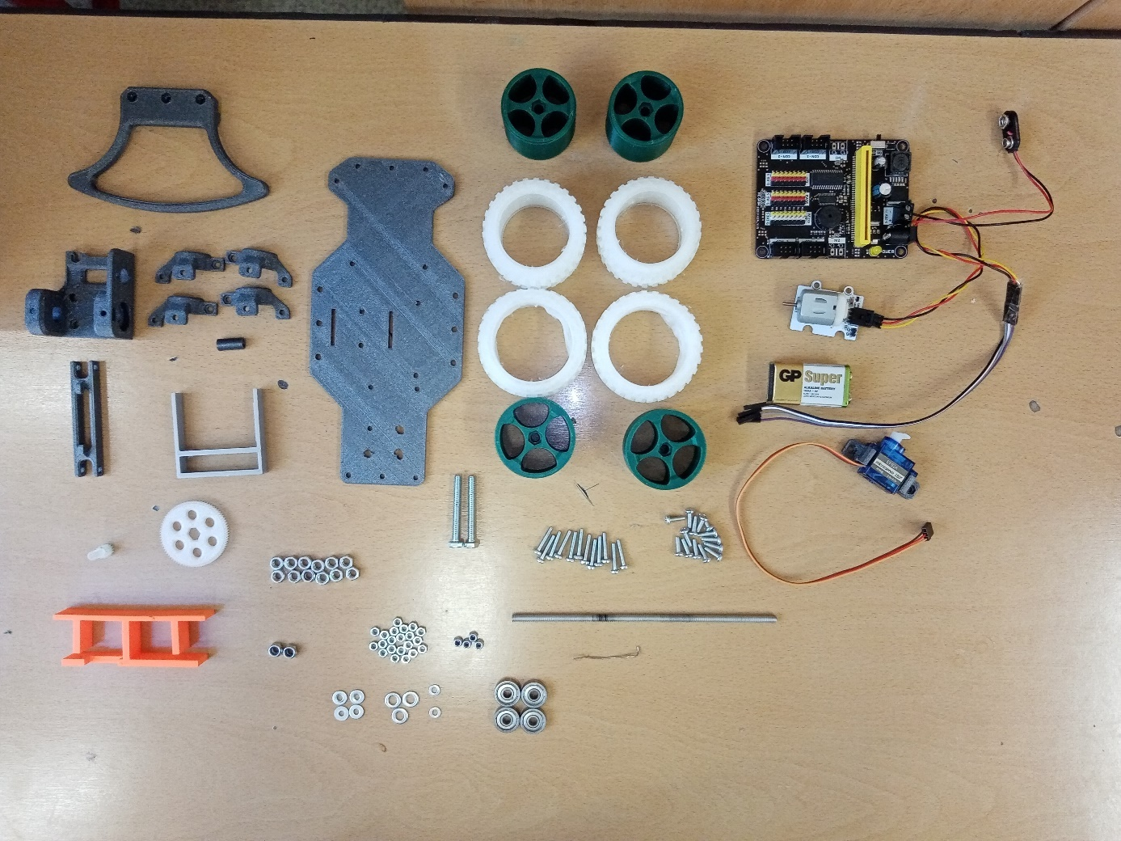

• Use any PLA filament for printing. The only exception is the gear and pinion, which must be printed from hard PLA or PETG filament. Filling 15 %, layer height 0.2 mm.
• The tires are printed from Flex type filament and it is very advisable to use a large layer of glue (Kores) when printing, the fixing spray was not very effective.
List of parts for building a micro:bit car
3D printed parts:
1. basic support plate | 1 pc
2. front bumper | 1 pc
3. lower bearing holder | 2 pcs
4. upper bearing holder | 2 pcs
5. motor holder | 1 pc
6. demarcation piece | 1 pc
7. steering rod | 1 pc
8. rear axle gear | 1 pc
9. pinion 1 pc | 1 pc
10. cable holder 1 pc | 1 pc
11. battery holder 1 pc | 1 pc
12. servo holder 1 pc | 1 pc
13. front tire 2 pc | 2 pc
14. rear tire 2 pc | 2 pc
15. front wheel disc 2 pcs. | 2 pcs.
16. rear wheel disc 2 pcs | 2 pcs

Fasteners:
1. threaded rod 5 mm, length approx. 16 cm | 1 pc
2. screw M5 x 40 | 2 pcs
3. screw M3 x 10, semi-round head | 16 pcs
4. screw M3 x 16, semi-round head | 15 pcs
5. nut M5 | 10 pcs
6 M5 locking nut | 4 pcs
7. M3 locking nut | 20 pcs
8. M3 locking nut | 4 pcs
9. M5 washer | 4 pcs
10. M3 washer, large | 4 pcs
11. M3 washer | 2 pcs
12. wire d=1 mm, 6 c | 1 pc
13. bearing 625 | 4 pcs

Micro:bit components
1. motor 3–5 V | 1 pc
2. 180°servo 3–5 V | 1 pc
3. base plate with stab. 5–20 V source | 1 pc
4. basic connecting cable | 1 pc
5. connecting cable extension | 1 pc
6. chip | 1 pc
7. 9 V battery | 2 pcs

2. Engine storage
- We have to modify the motor holder slightly with a sander so that the micro:bit motor itself can be inserted into it, see picture.
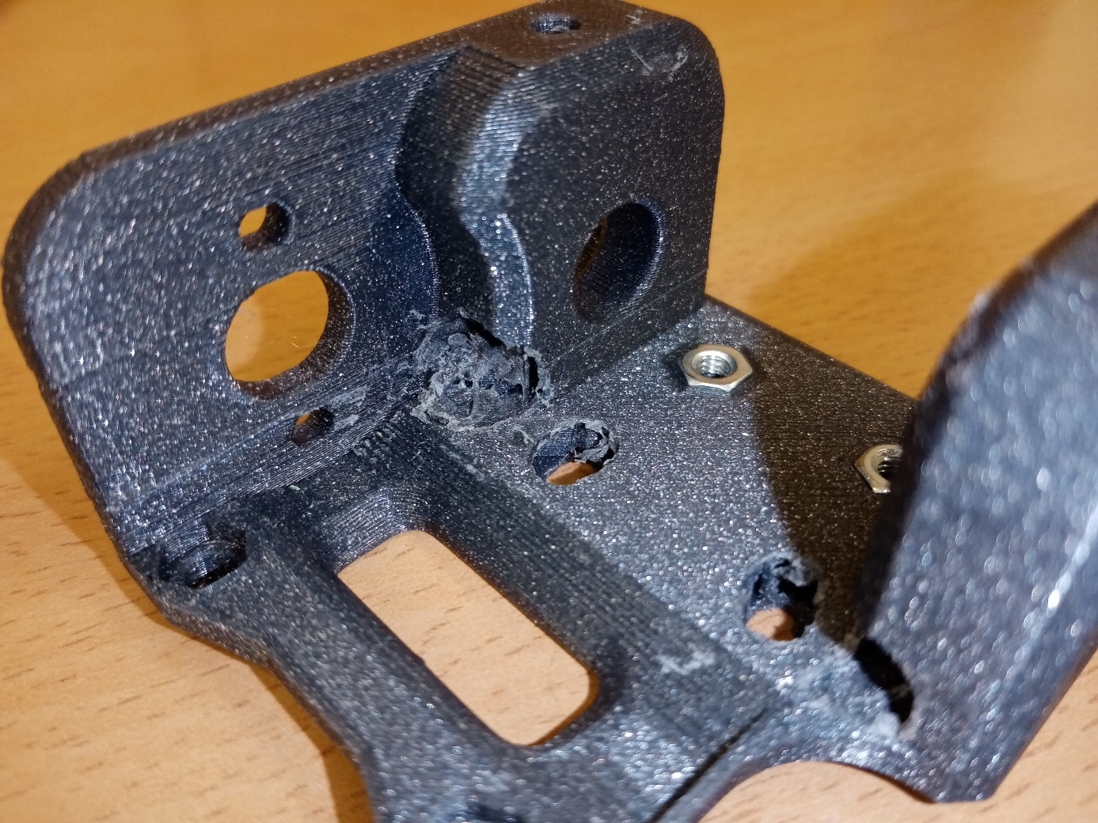
- Attach the modified motor holder as shown in the picture to the base support plate and drill 3 mm diameter holes in the base support plate according to the motor holder. We connect both parts with two M3 x 10 screws and M3 nuts
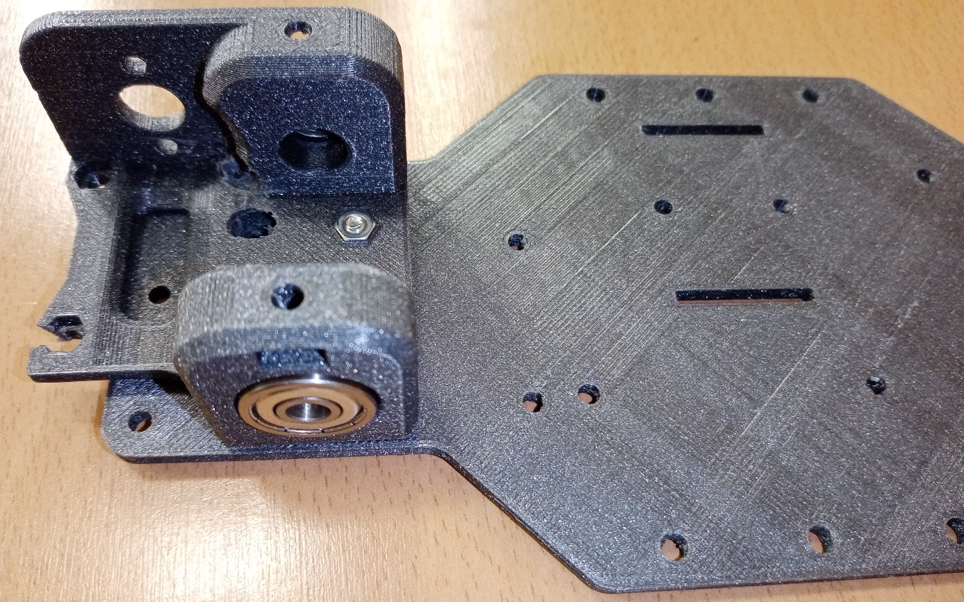
- We insert bearings 625 - 2x into the outer holes of the motor holder.
3. Servo holder
- The holder must be sanded slightly so that the servo cables are not damaged when inserted, see picture.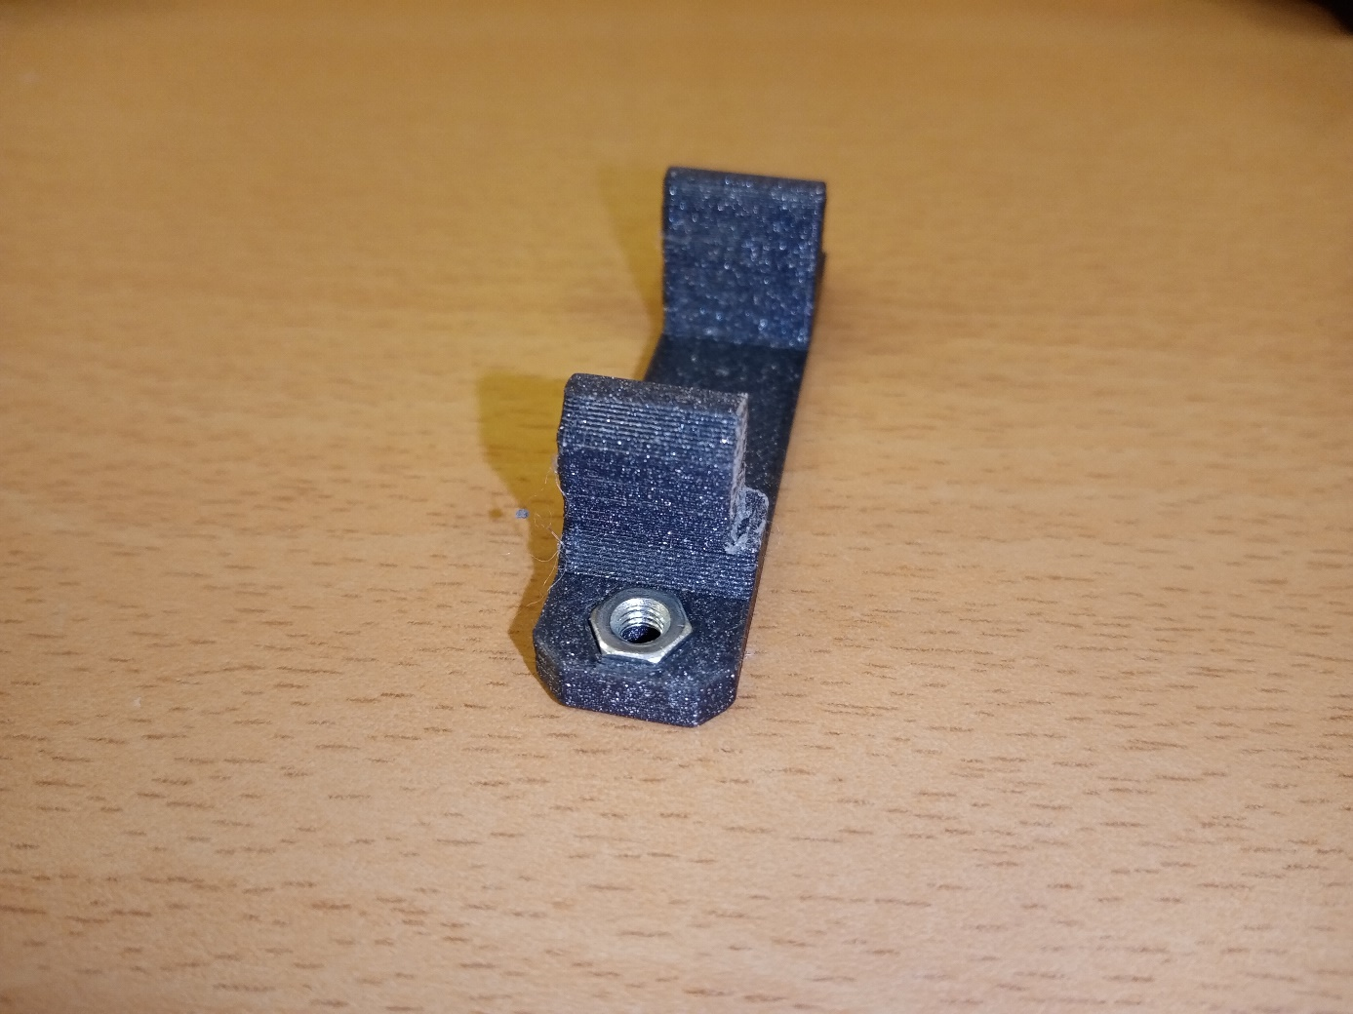
- We attach the servo to the holder with two screws (part of the micro:bit delivery).
- Using two M3x10 screws and M3 nuts, we connect the holder with the servo to the base plate.
- Set the servo lever to 90°
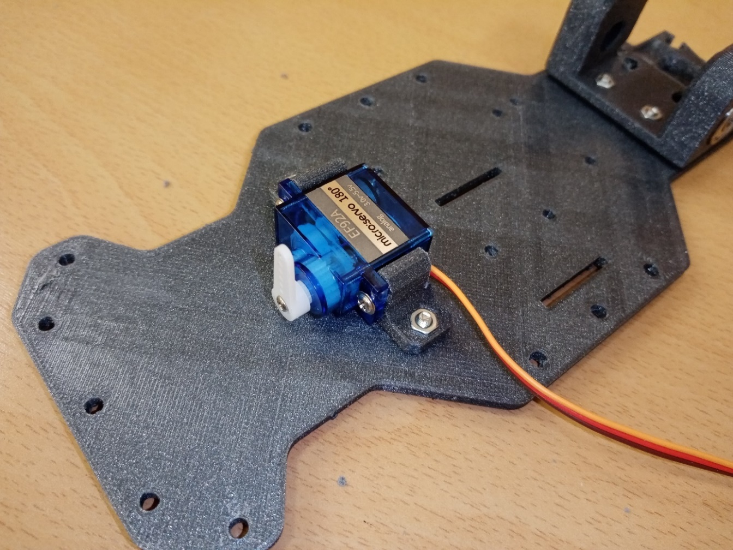
4. Management
- Insert the 625 bearing into the upper and lower bearing holder and connect it to the M3 nut with an M3 x 10 screw.
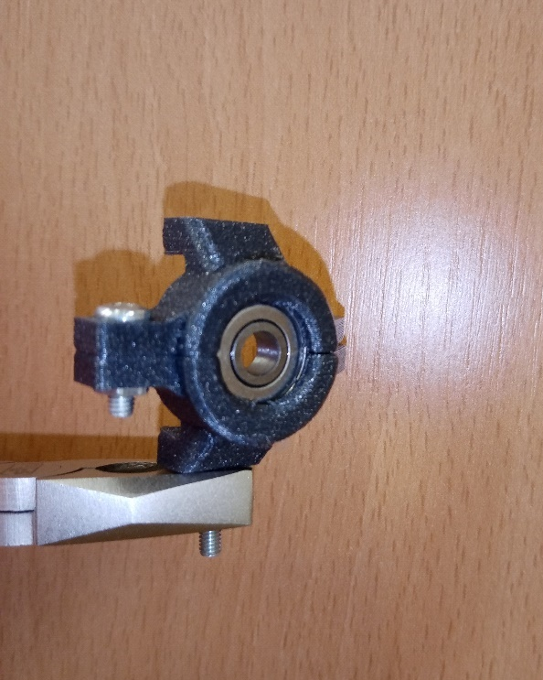
- We connect the steering rod to the correctly positioned brackets using two M3x16 screws and safety nuts
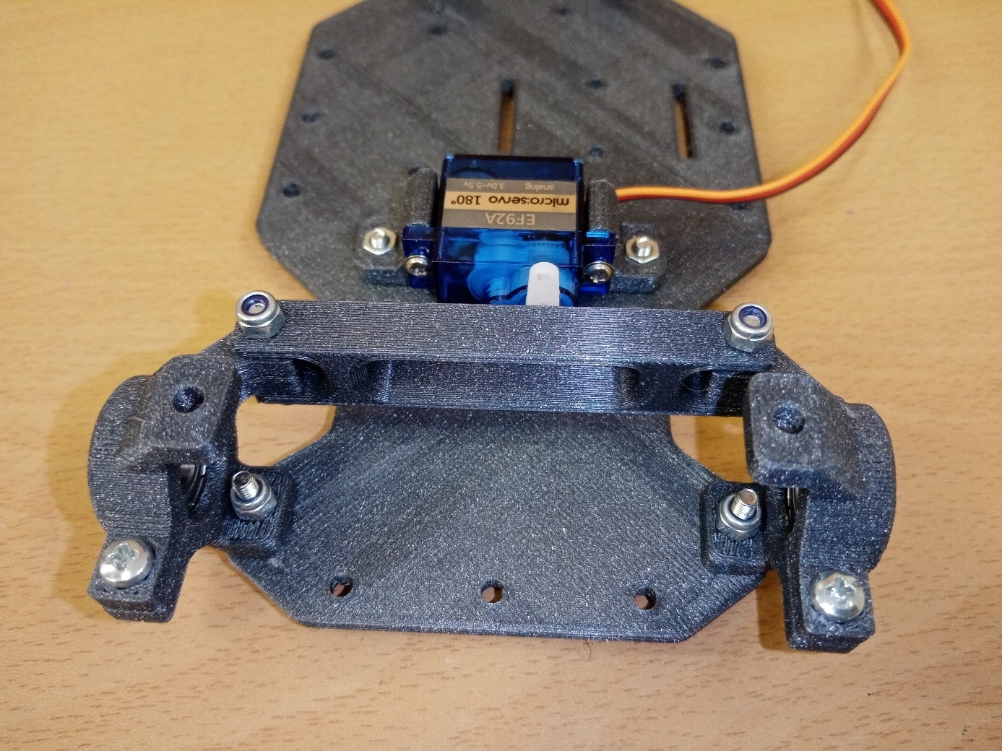
- We attach these connected parts to the base support plate with the help of an M3 x 16 screw. We will use safety nuts again and it is advisable to put an M3 washer under the head of the screw – large.
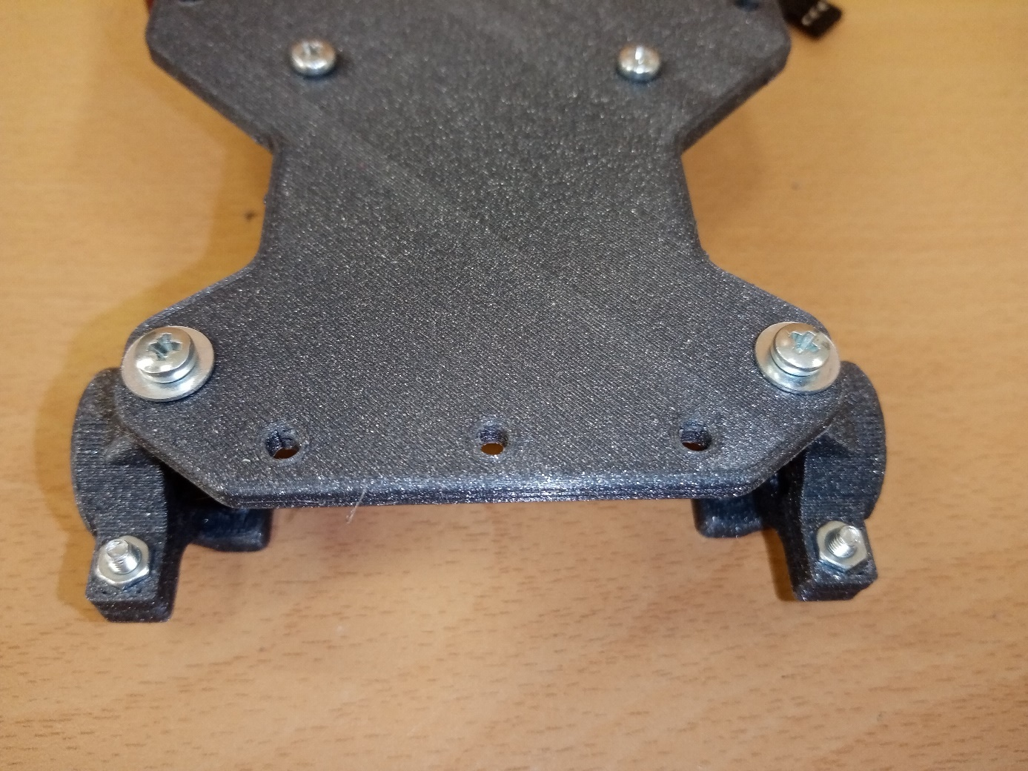

5. Front wheels
- Thread the front tire onto the front wheel disc.
- Insert the M5 nut in the center of the inner side of the disc.
- Insert the M5 safety nut in the center of the outer side of the disc. To insert the nut, it is recommended to screw the nut onto the beginning of the M5 x 40 screw and insert the nut by grasping this screw.
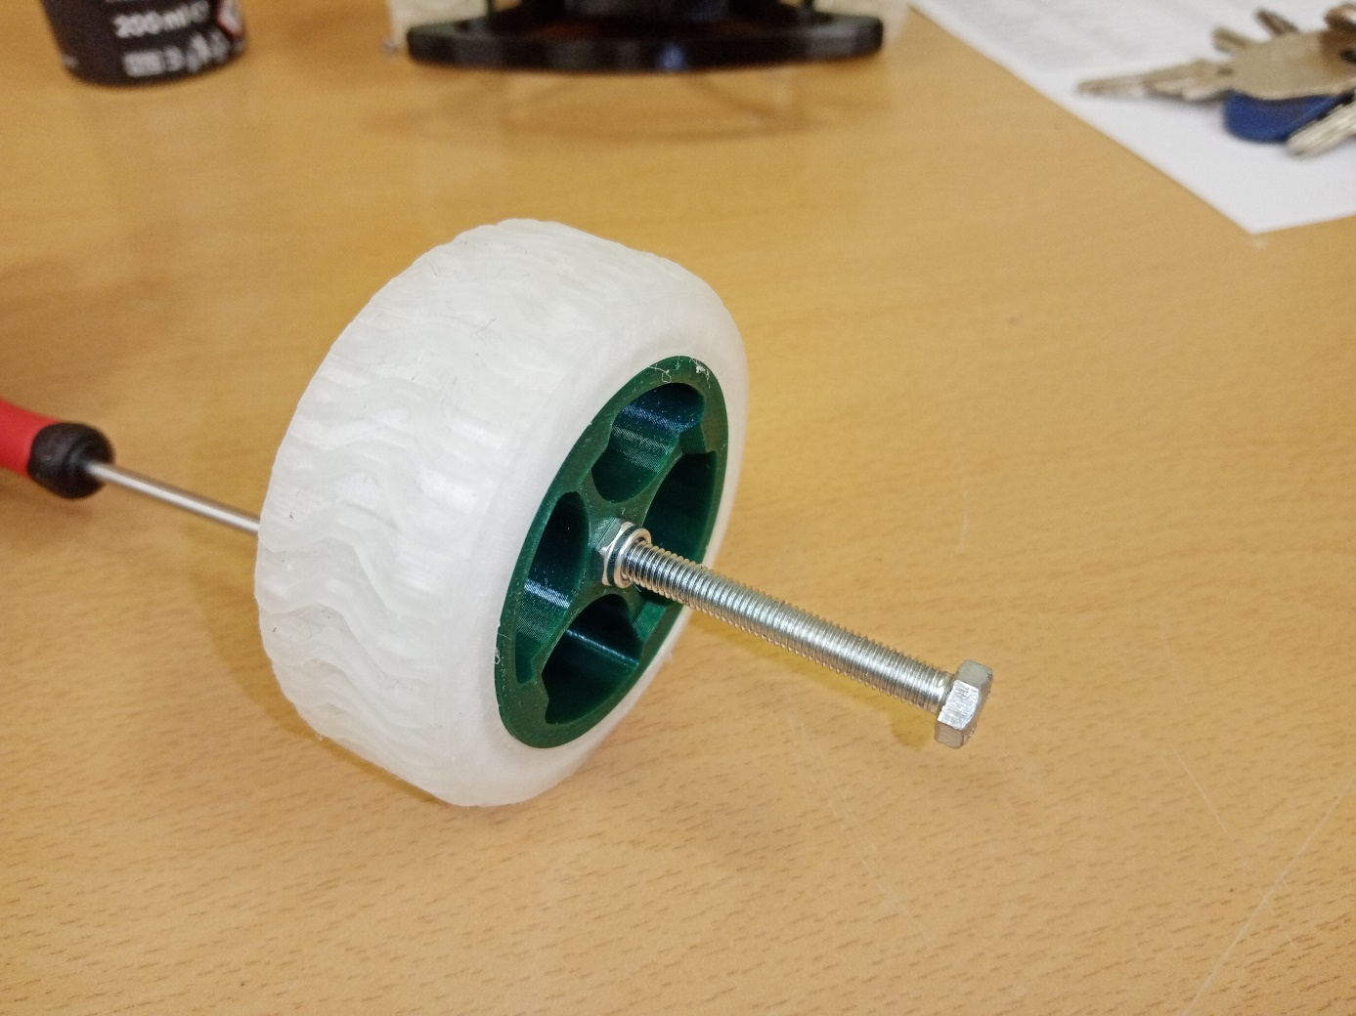

- Pass the M5 x 40 bolt through the 625 front axle bearing, hold the bolt head with a wrench or pliers, and screw the M5 nut onto the bolt.
- Then screw the front wheel onto the M5 x 40 screw.

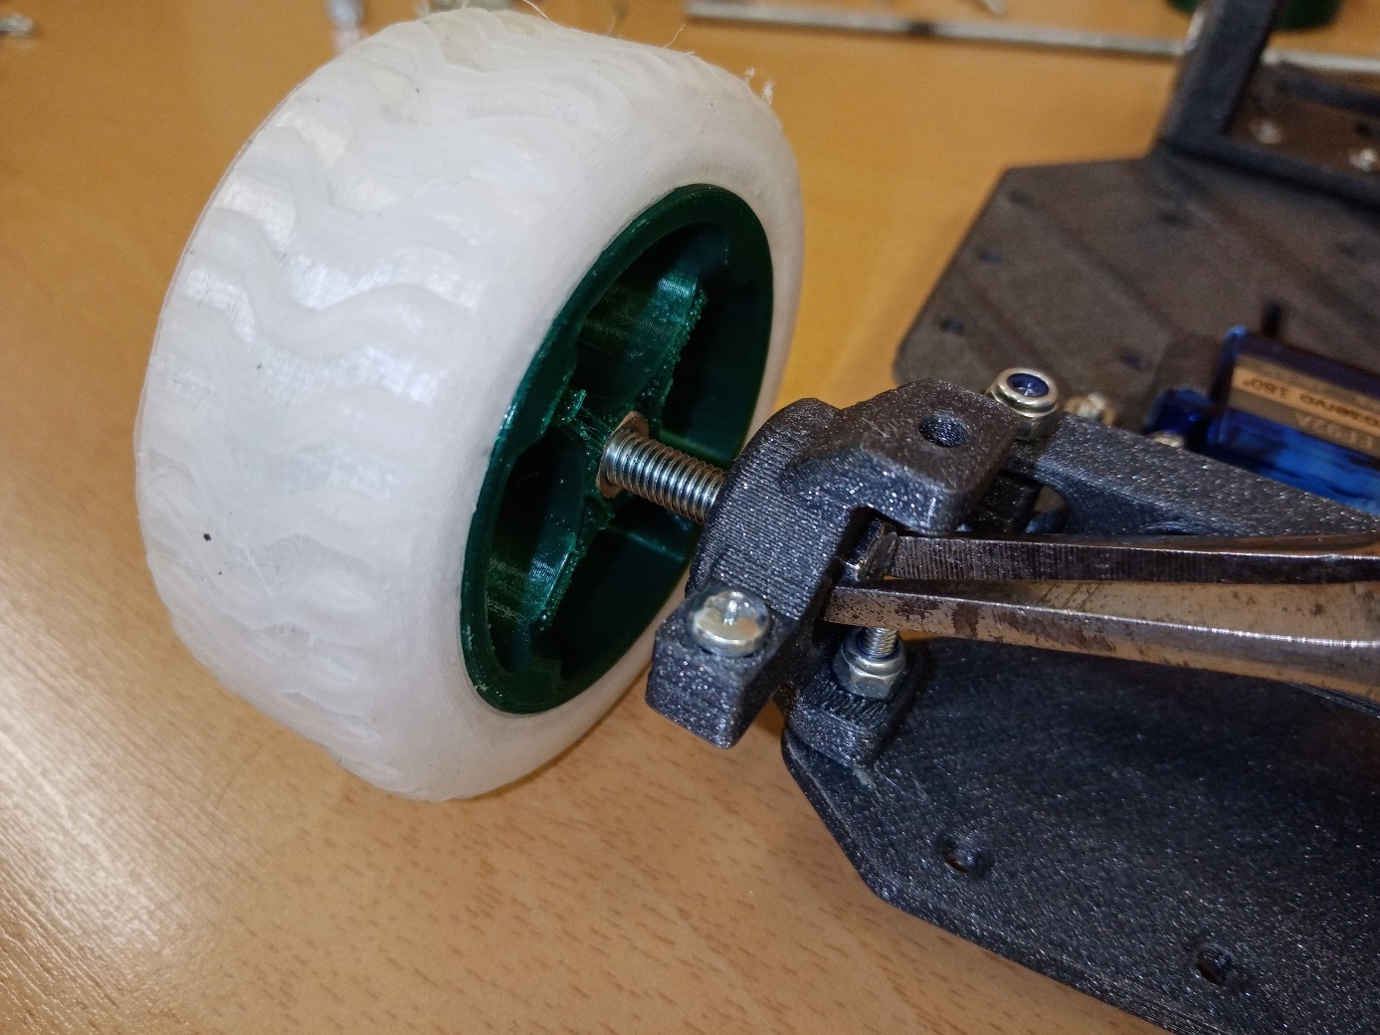
6. Front bumper
- Place the front bumper on the front of the base plate and fasten it with three M3 x 10 screws with M3 nuts.
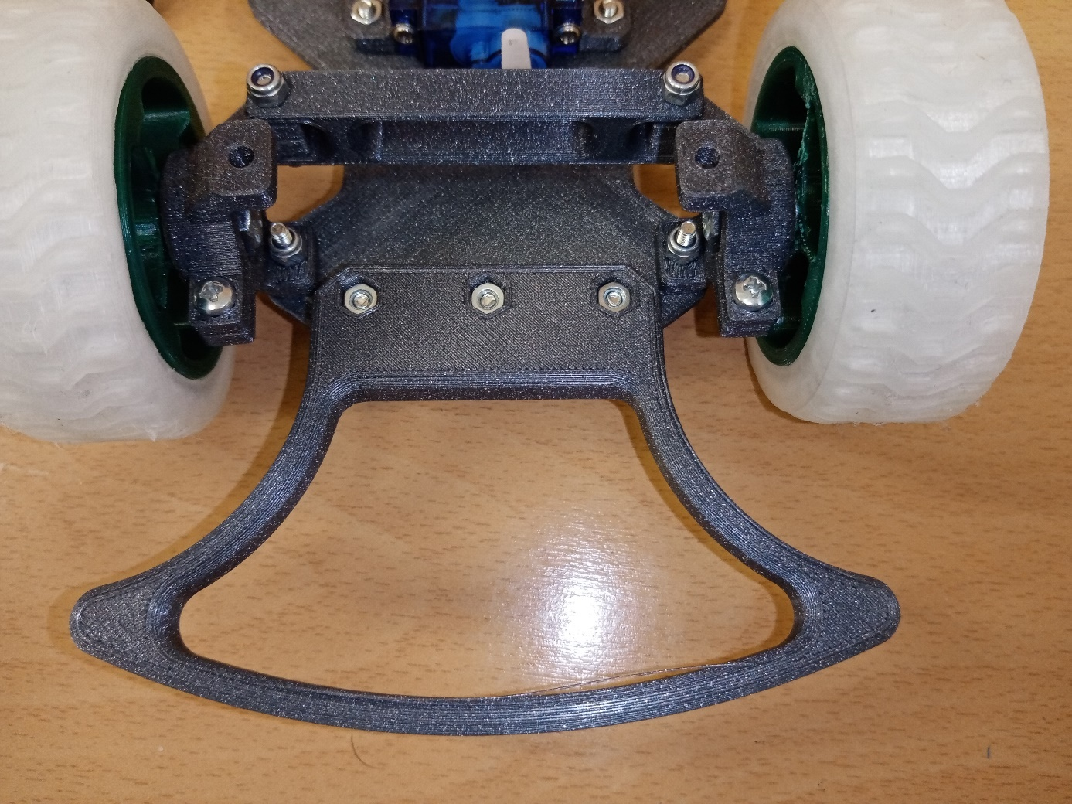
7. Rear axle
- Thread the rear tire onto the rear wheel disc. Insert the M5 nut in the center of the inner side of the disc. Insert the M5 lock nut in the center of the outer side of the disc. To insert the nut, it is recommended to screw the nut onto the beginning of the M5 x 40 screw and insert the nut by grasping this screw.
- Screw one tire disc onto the 5 mm threaded rod and thread the spacer.
- Next, screw the M5 nut onto the rod. Insert the rod into the bearings in the motor holder so that
- The wheel is located on the right side of the base support plate.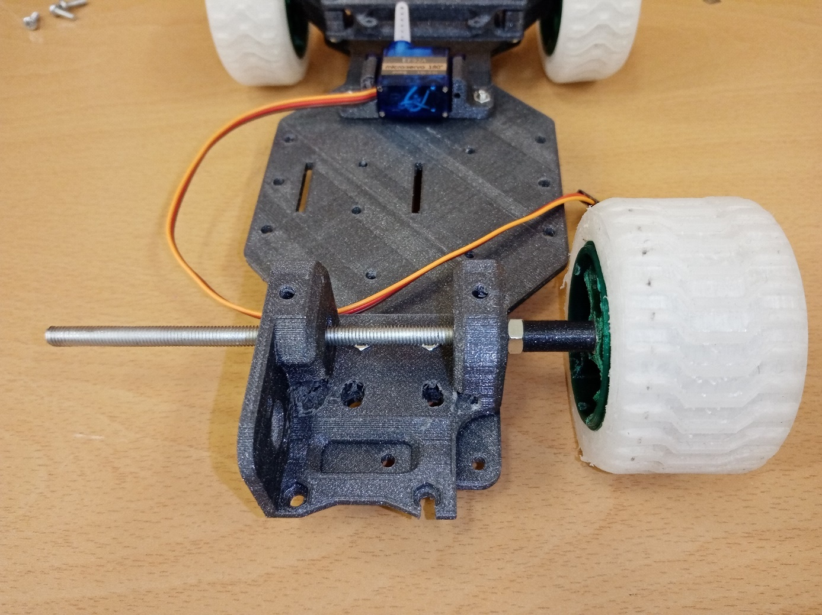
- Screw two M5 nuts onto the rod up to bearing 625. Be careful not to block the bearings by over tightening the nuts.
- Insert the M5 nut into the gear, thread the M5 washer onto the rod, and screw the gear onto the rod close to the washer and the two M5 nuts. When tightening, fix the rod in the space between the bearings with pliers.

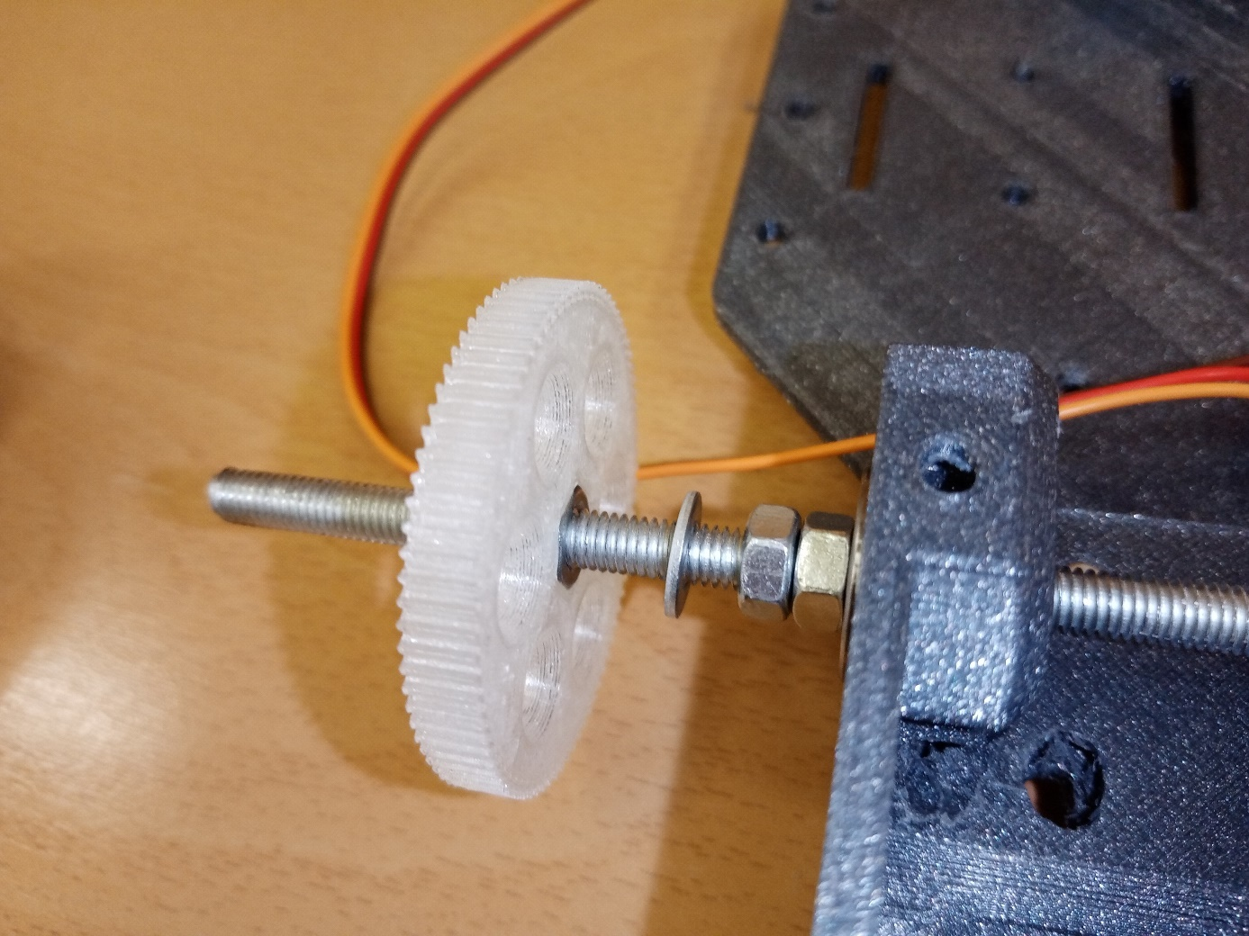
- Put another M5 washer on the rod and fix the gear with two M5 nuts. Screw the second rear wheel onto the bar. Check that the rear drive axle rotates easily in the bearings. Otherwise, adjust the tightening of the nuts.
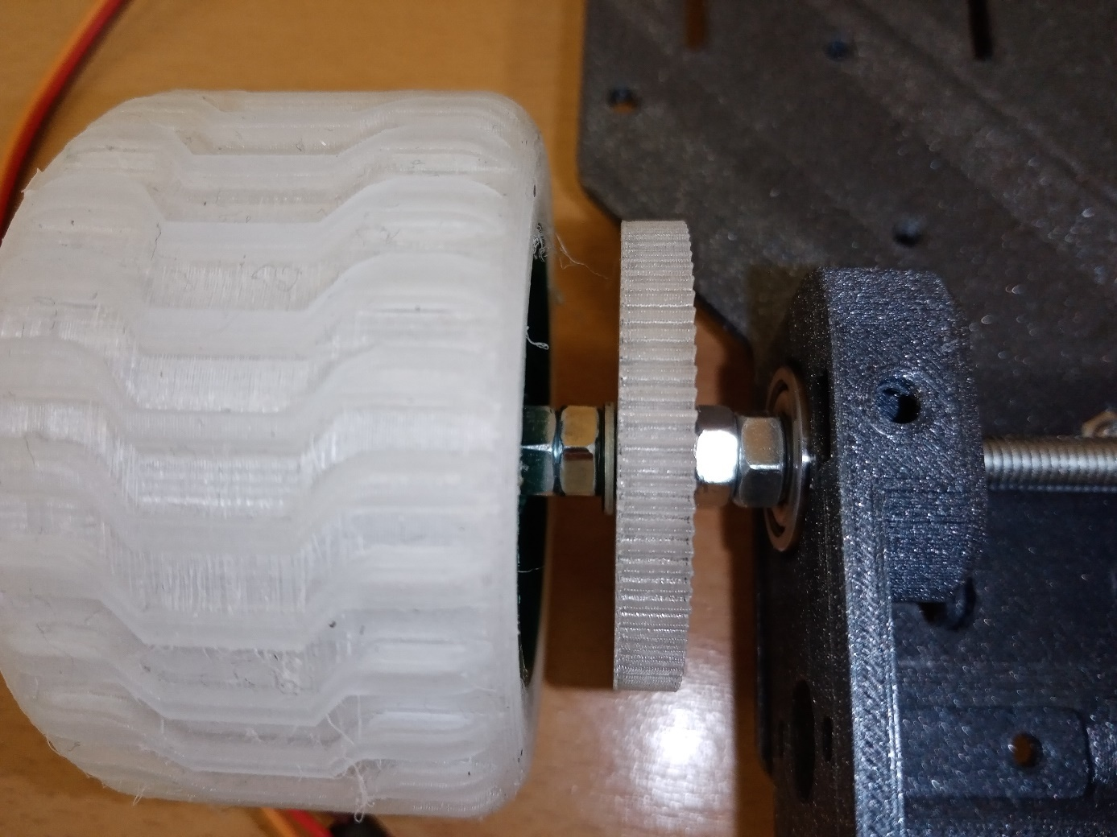

8. Battery holder
- Using two M3x10 screws and two M3 nuts, attach the bracket to the base support plate with the cut-out at the top facing the front wheels.
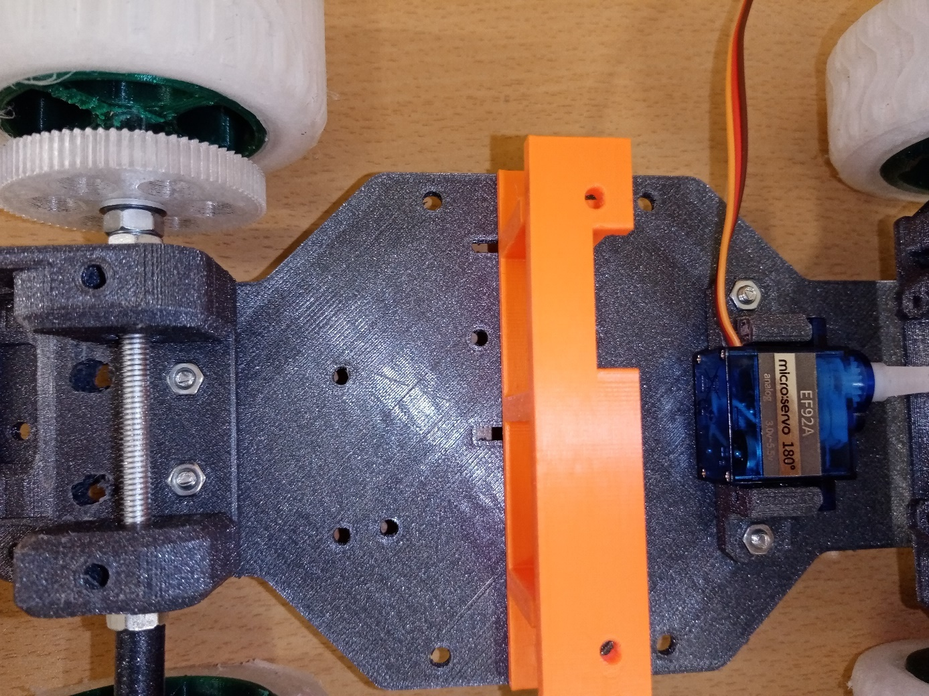
9. Engine installation
- Slide the pinion onto the motor shaft
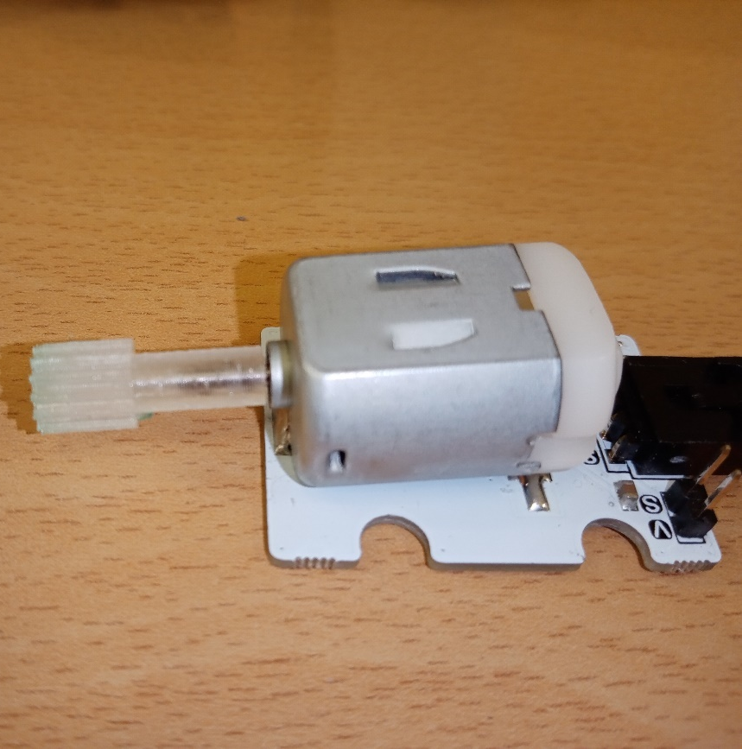
- Insert the motor into the hole of the motor holder so that the pinion is in the appropriate position relative to the gear wheel.
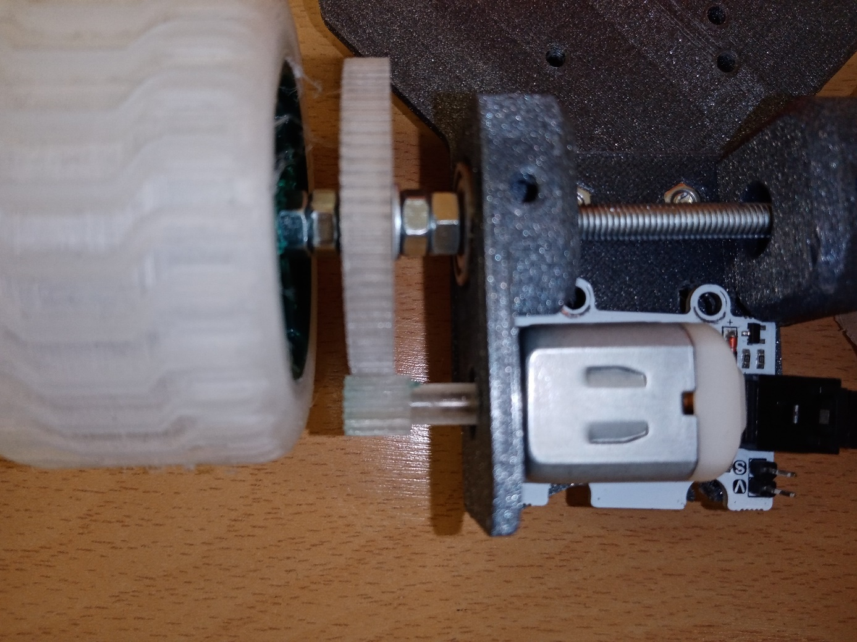
- Mark the position of the two holes in the motor plate on the motor mount. Slide the motor out and drill a 3 mm diameter hole in the marked places.
- Reinsert the motor into the bracket and secure it to the motor bracket and base plate using two M3x16 screws and two M3 nuts

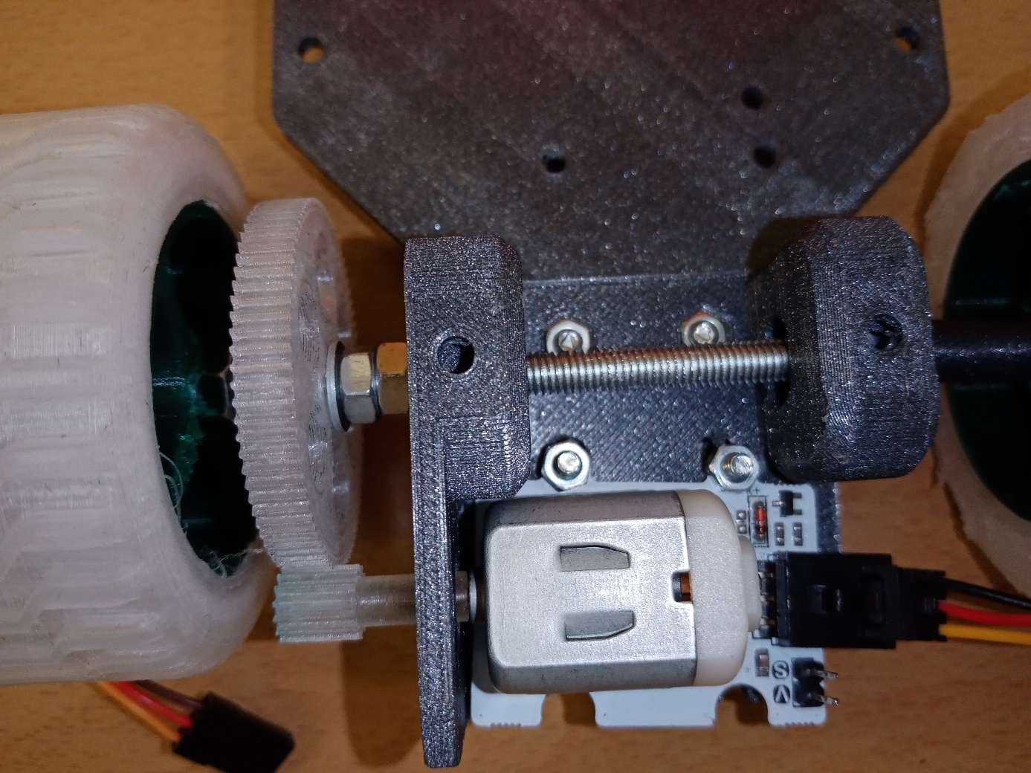
- Make sure the motor shaft rests properly on the gear and the gear can easily be turned over the rear wheels
10. Installation of steering rod control
- From wire with a diameter of 1 mm, we shape the control of the steering rod. We bend the wire at the ends appropriately and shorten it, carefully slide it first on the steering rod and then on the servo lever.
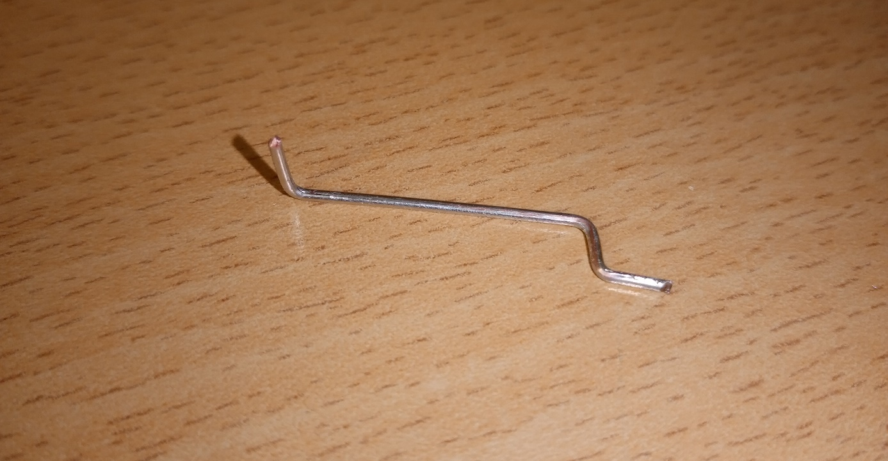

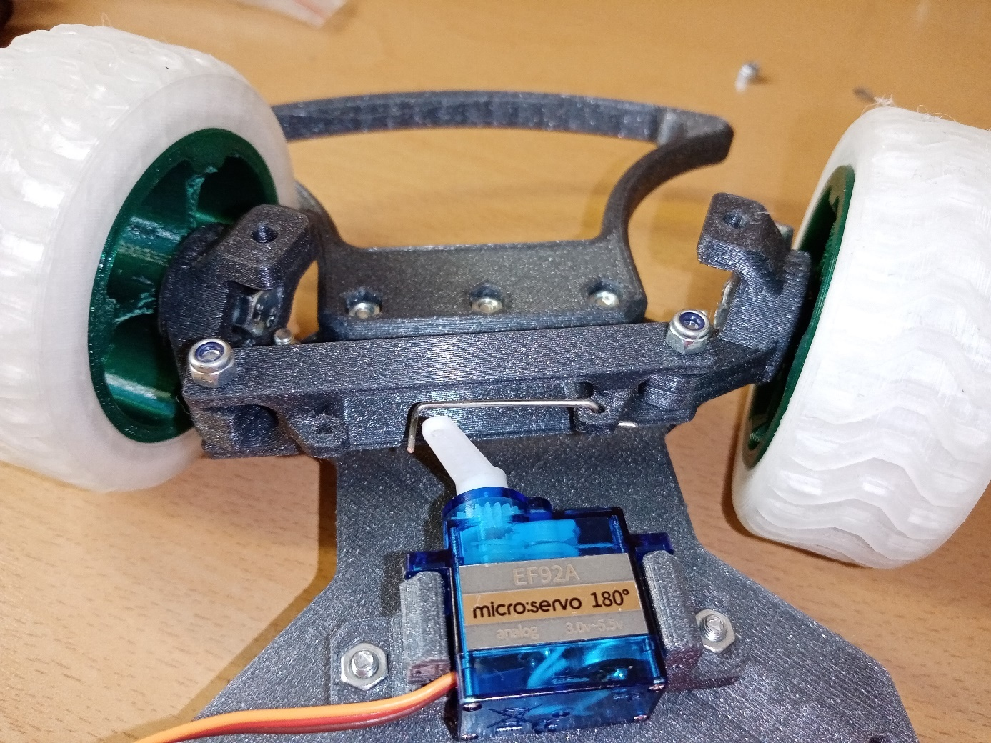
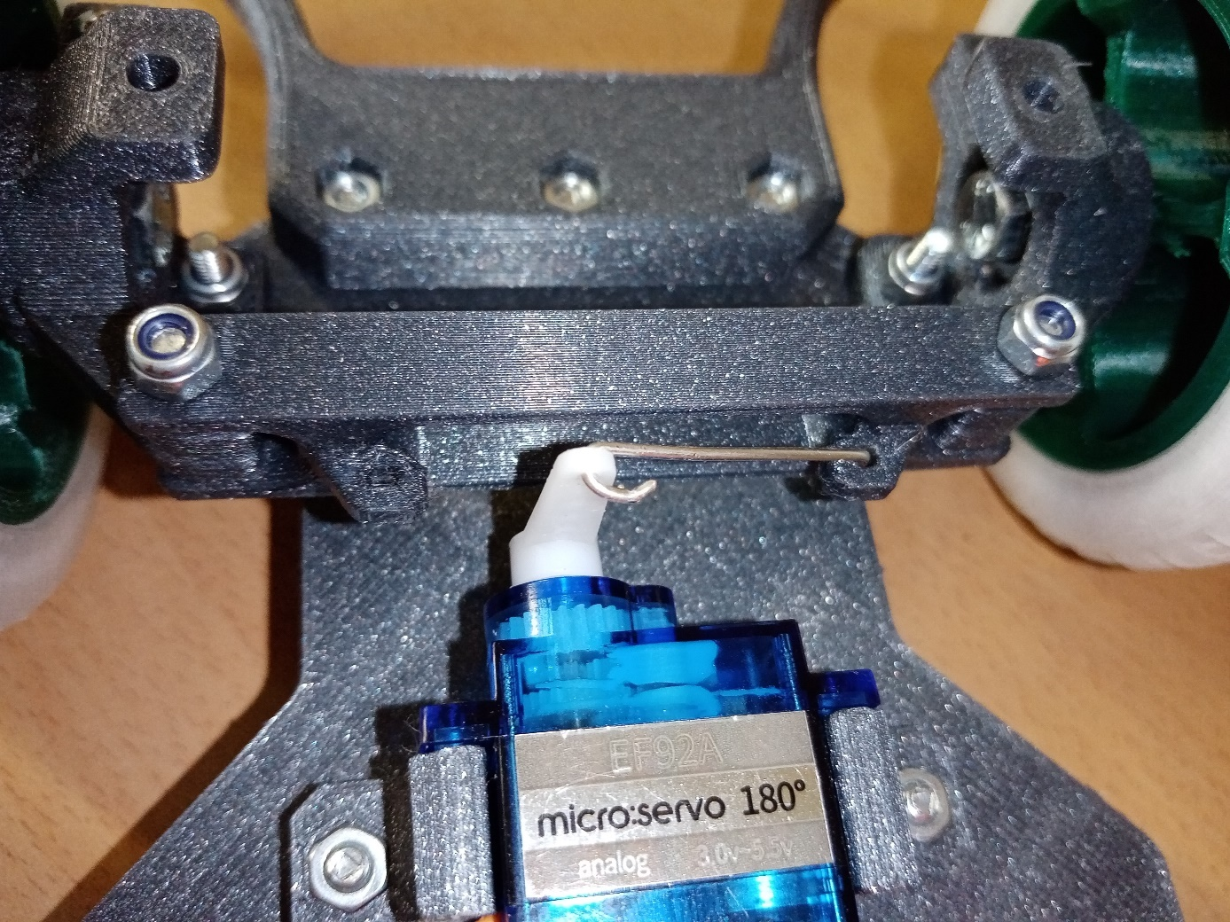

11. Installing the micro:bit motherboard
- Fasten the plate with four M3 x 10 screws through the four holes in the plate, two of them with M3 lock nuts will be located on the upper parts of the upper bearing holder (front axle), the other two will connect the plate to the battery holder. Tighten the bolts on the front axle only gently.

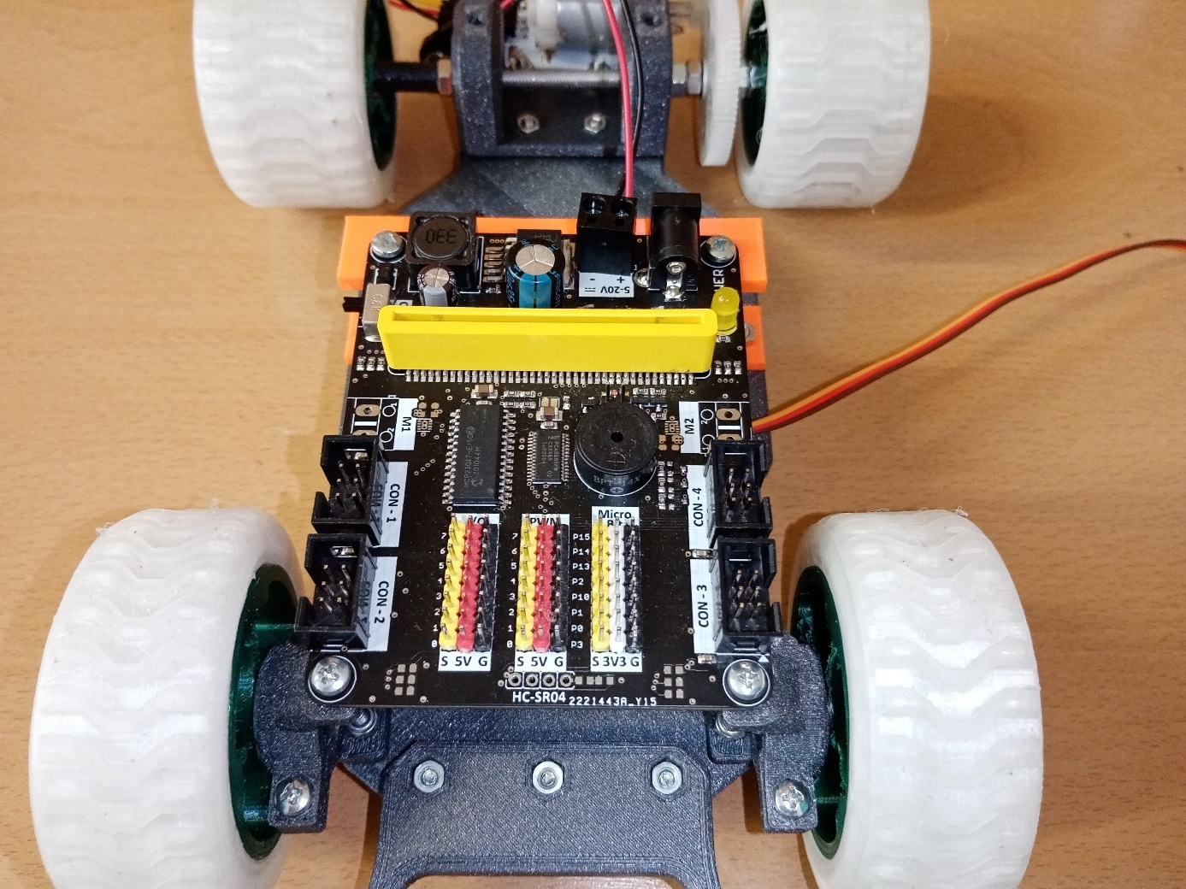
12. Installation of the cable holder
- Attach the bracket to the motor bracket using two M3 x 10 screws and two M3 nuts. Insert the screw through the hole of the cable holder and insert the M3 nut into the slot of the motor holder. Tighten with a curved Phillips screwdriver. If a suitable screwdriver is not available, drill two suitable holes in the upper strip and tighten the screws through them.

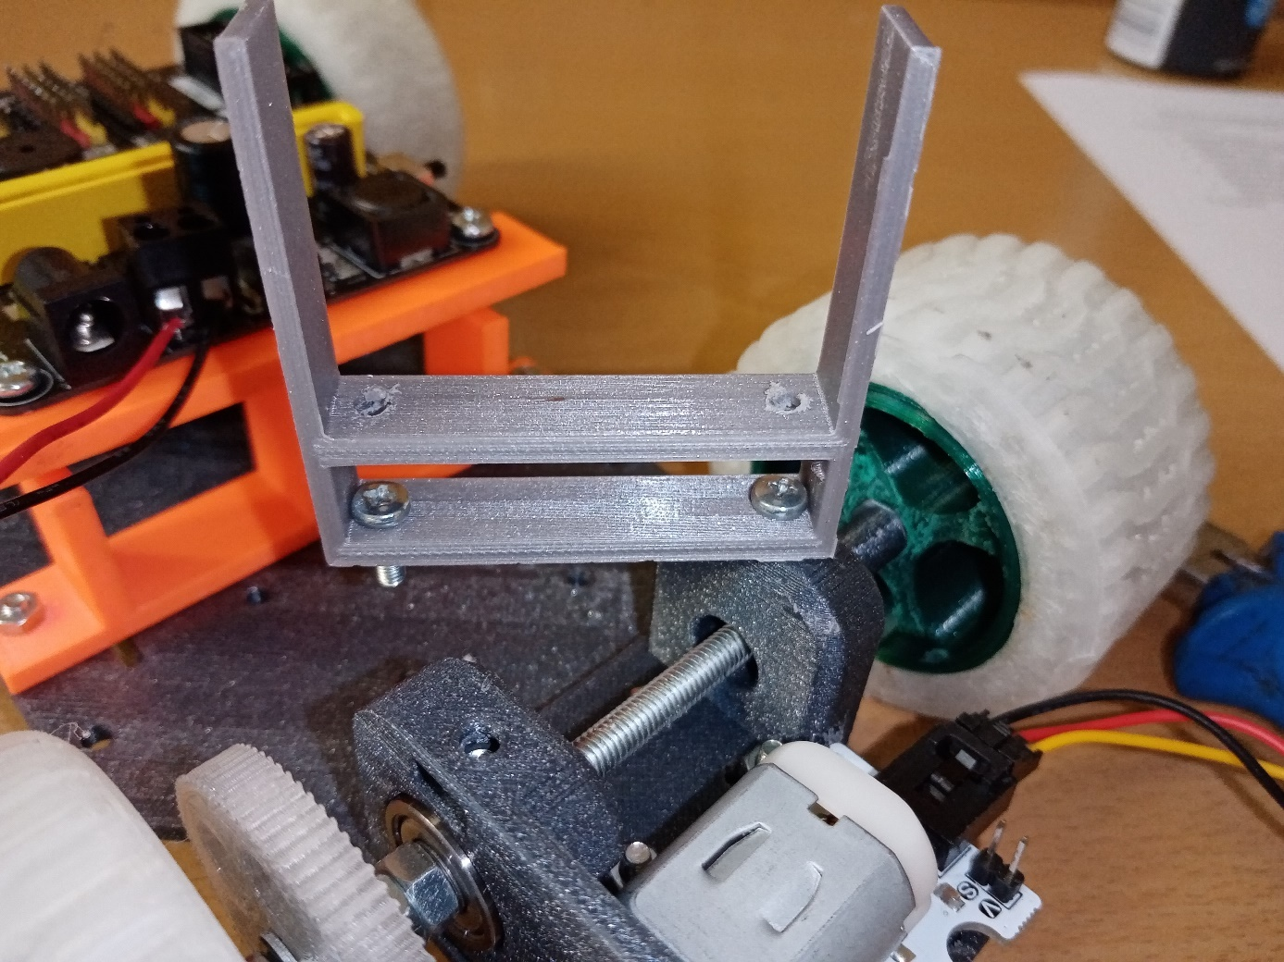

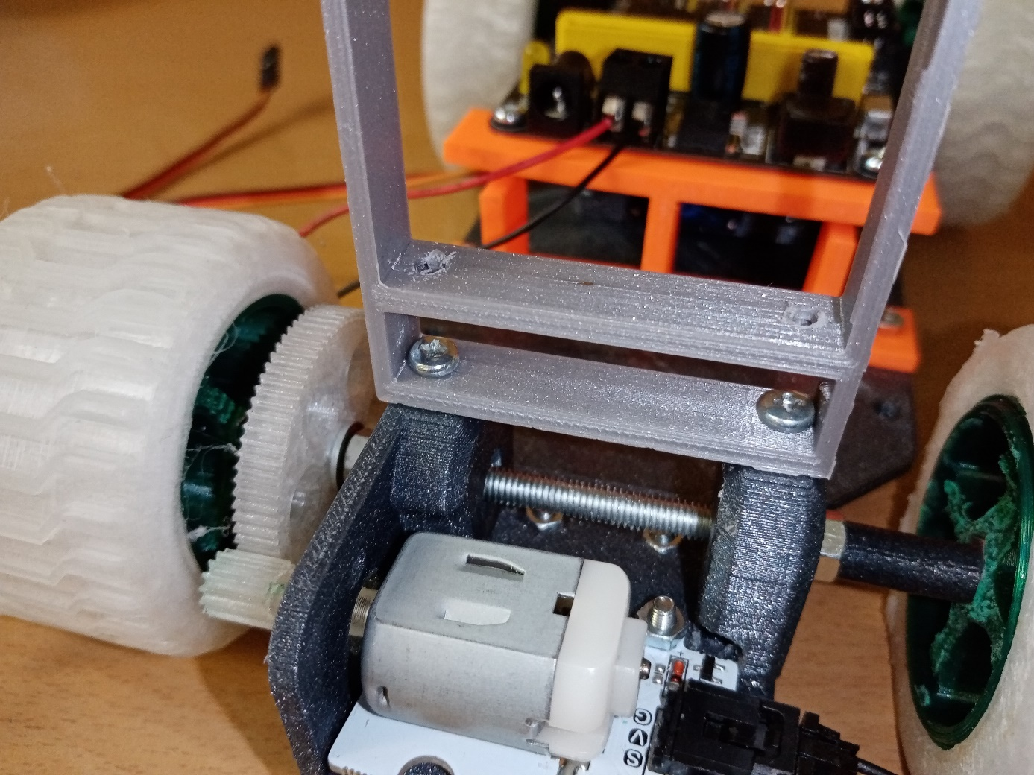

13. Cabling
- According to the picture, connect and insert the 9 V battery on the connected connector
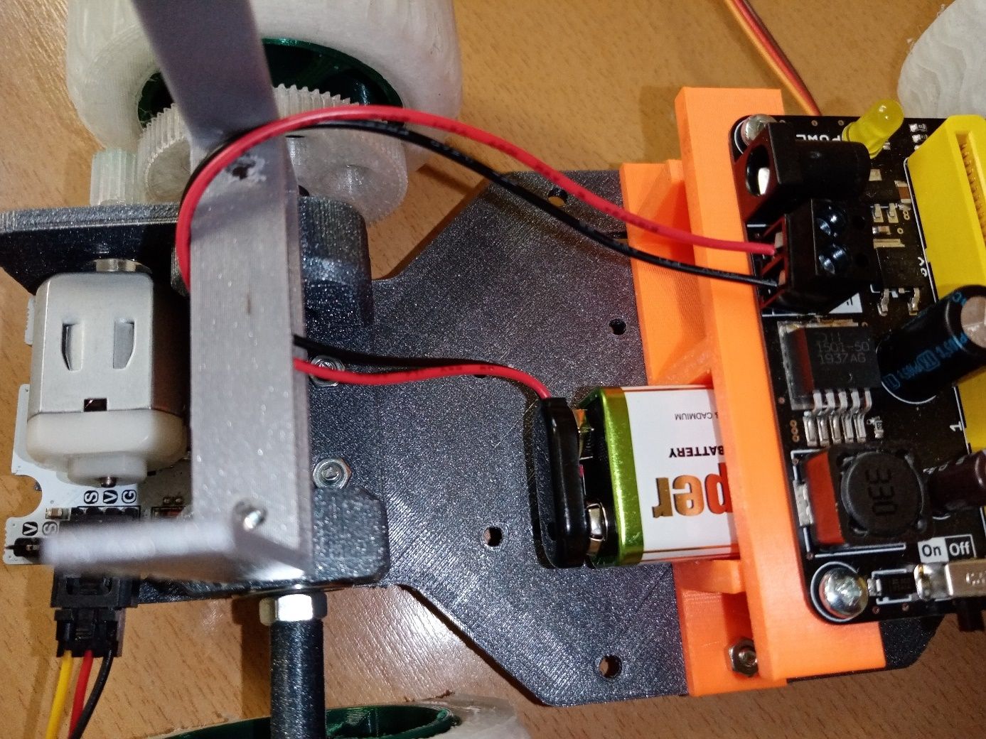
- Plug the motor power cable into the motor connector, connect the connection cable to the power cable (one wire will be free), secure the cable connection with tape, wrap the connected cables several times around the cable holder
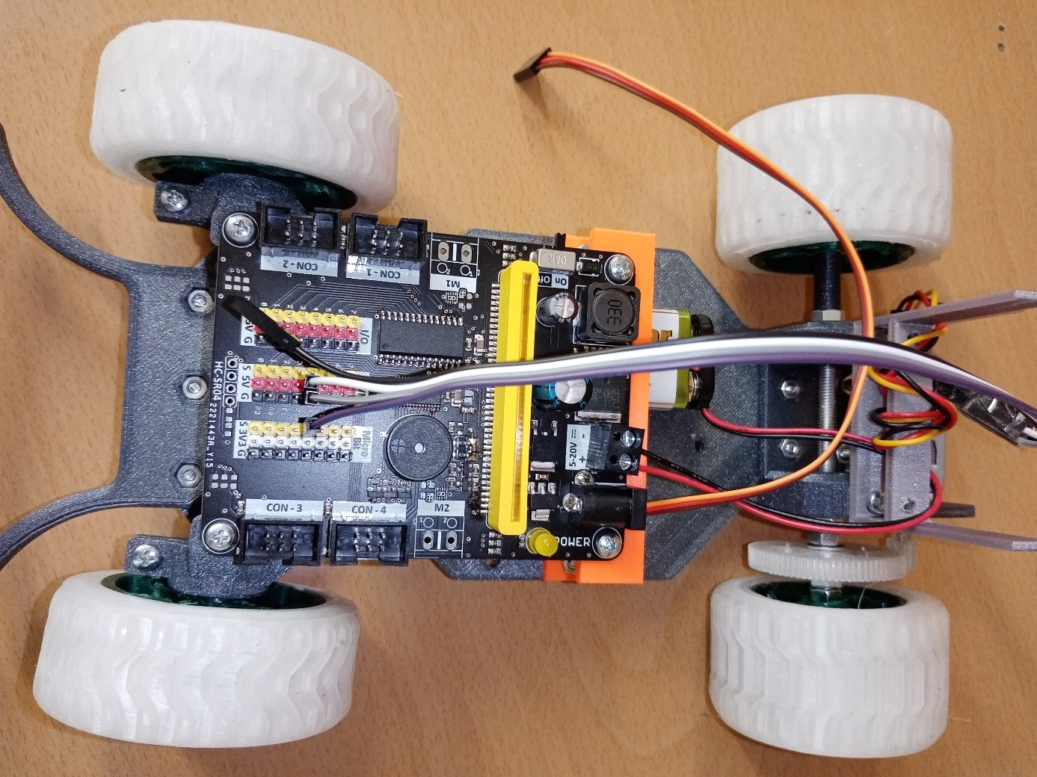
- Connect the yellow cable to the S PIN 2-3 V and the black and red to the V and G PIN 2-5 V with the connecting cable
- Connect the cable from the servo to PIN1 – 3V
- Carefully check that the corresponding wires are connected to each other
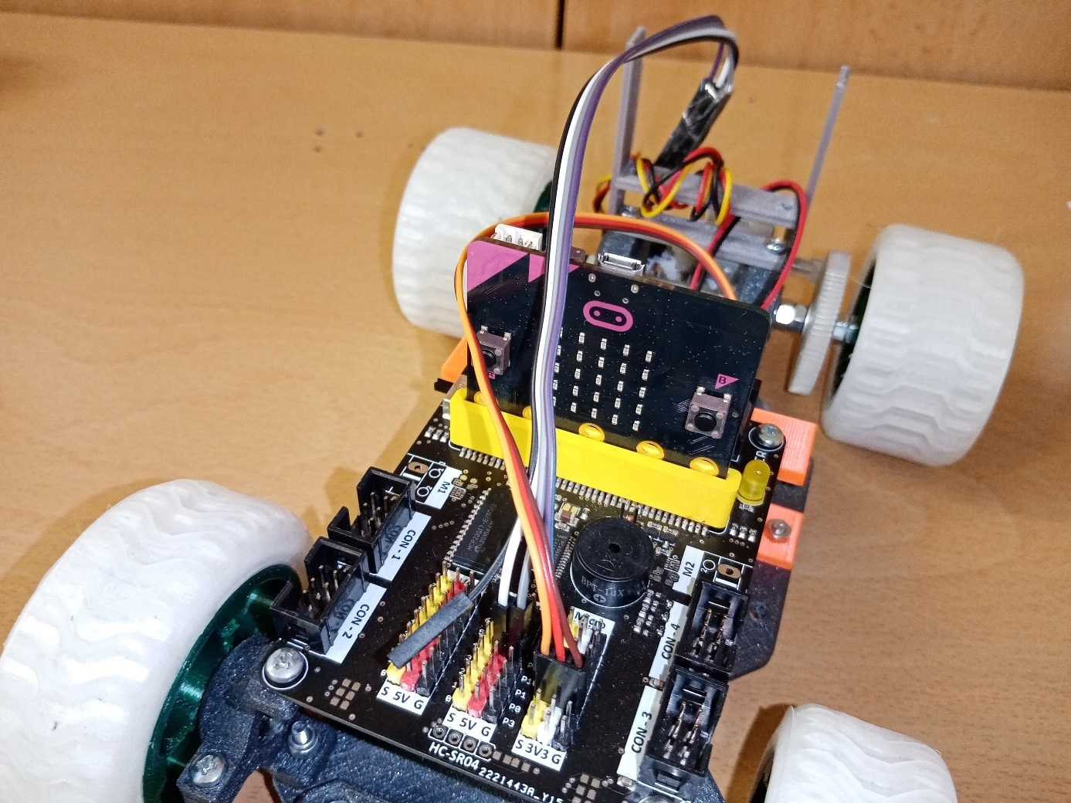

14. Software
- In the application https://makecode.microbit.org/ you create a program:
- Upload the program to the micro:bit chip
- Insert the chip into the socket of the micro:bit base plate
- Download the EV-micro:bit application to your mobile phone via the Play Store
- You pair the application with the micro:bit chip
- After pairing and several necessary unsuccessful attempts, the toy car starts
